
A
Practical Assignment
On
Python Programming Lab Assignment

RUNGTA INTERNATIONAL SKILLS UNIVERSITY

SESSION: 2025-26

Submitted By:-
Subject teacher name :- Sudeep Sarkar
Miss Kavita Kanwar ERP :- RU-25-11468

RUNGTA INTERNATIONAL SKILLS UNIVERSITY,CG
SCHOOL OF INFORMATION TECHNOLOGY

INDEX
S.No | Name of  Practical | Submission  Date | Remarks
1. | Print following
1. | patterns:
1. | 1
1. | 12
1. | 123
1. | 1234
1. | 12345
1. | *
1. | ***
1. | *****
1. | *******
1. | *
1. | * * *
1. | * * * * *
1. | * * *
1. | *
1. | ***
1. | * *
1. | * *
1. | ***
1. | * *
1. | *
1. | * *
2. | Write to find the probability of rolling a dice/flipping a  coin.

3. | Write a program to find factorial of a number using recursion.
4. | Write a program to search for an item in a user- provided list and display the position if found, otherwise print “item not  found.”
5. | Given a list of employee records as dictionaries, sort them by salary and display the sorted list.
6. | Write a program that reads a text file and counts the number of lines, words and characters.

7. | Read a sentence and display how many times each word appears, ignoring case and punctuation.
8. | Write a Python program that lists all files in a directory and categorizes them by file extension.
9. | Inside the circle.py module, create a class Circle that demonstrates by using a separate Point class (for center coordinates). Write the code for both classes
10. | Add an _init_.py file inside the shapes package that exposes only Circle and Rectangle using _all_. Write code to show how from shapes import * will work after this.
11. | Write a program in main.py to import the shapes package using both:  - Absolute imports  - Relative imports (inside package)
12. | Write a Python program that reads two numbers from the user and performs division. Use try-except to handle the following exceptions:  - ValueError (if the user enters non-numeric input)  - ZeroDvisionError (if the second number is zero)  - Display appropriate error messages.
13. | Create a Python function read_file(filename) that opens and reads a text file. Use try-except-finally to handle:  - FileNotFoundError if the file does not exist  - PermissionError if the file cannot be opened  Finally FileNotFoundError block should print “File read attempt completed.”
14. | Use California Housing datasets to build a Linear Regression model and print MAE and R² score.
15. | Perform Agglomerative Hierarchical Clustering on the Iris dataset.

Practical - 1
Aim : Print Following patterns

(a) 1
12
123
1234
12345
(b) *
***
*****
*******
(c) *
* * *
* * * * *
* * *
*
(d) * * *
* *
* *
* * *

(e) * *
*
* *

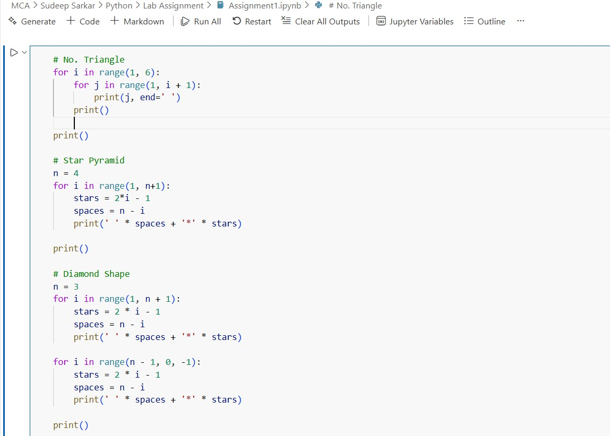
Code :-

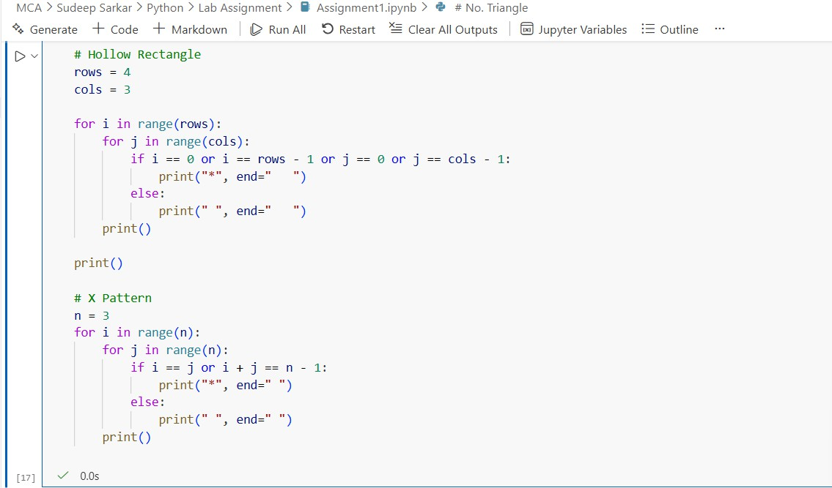

Output :
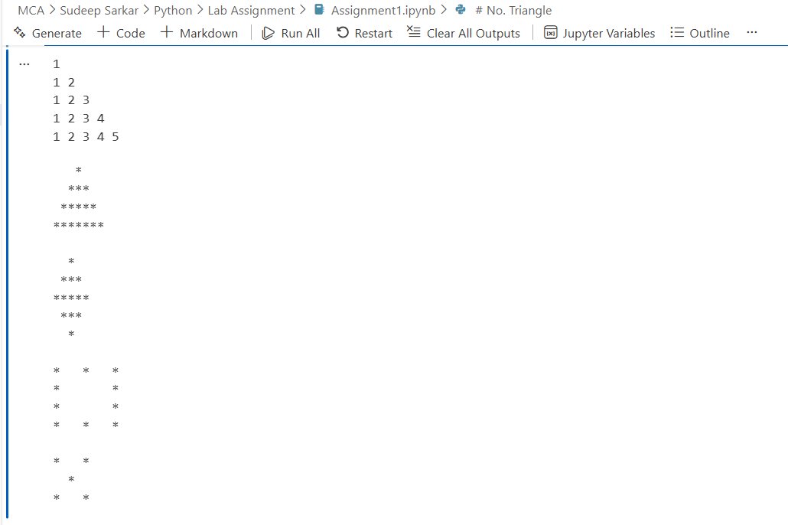

Practical – 2
Aim: Write to find the probability of flipping a coin
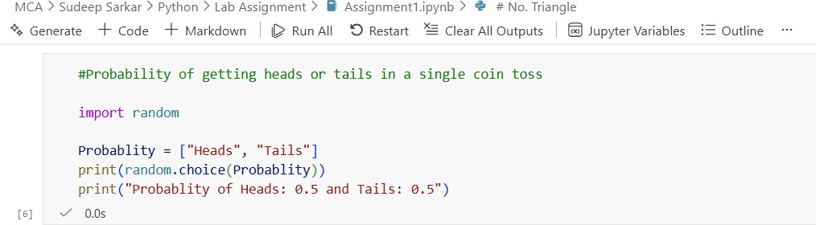
Code :

Output :
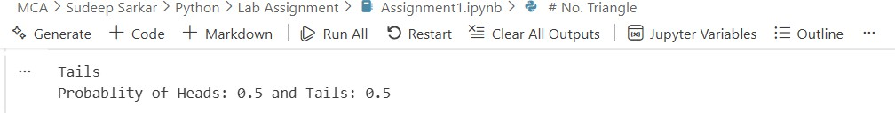

Practical – 3
Aim : Write a program to find factorial of a number using recursion.
Code :
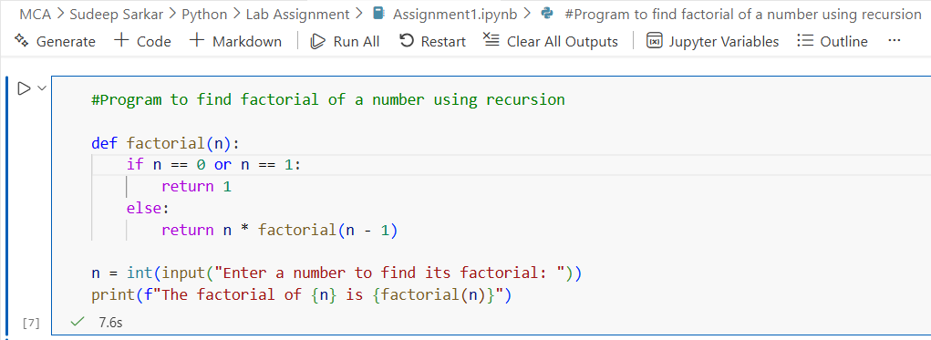

Output :
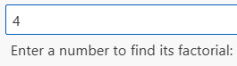

Practical – 4
Aim : Write a program to search for an item in a user-provided list and display the position if found, otherwise print “Item not found.”

Code :

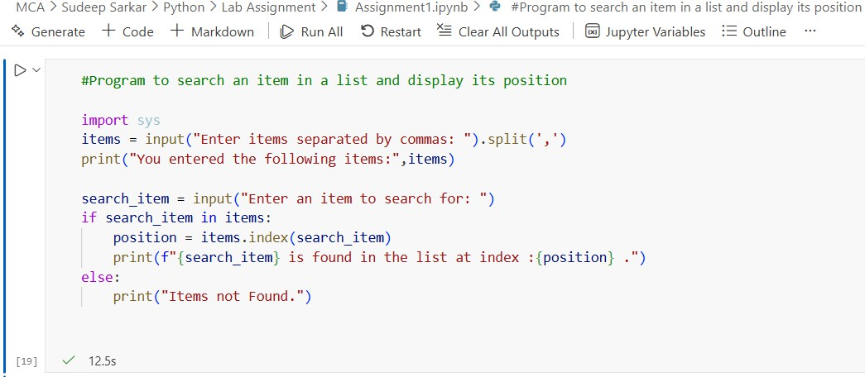

Output:
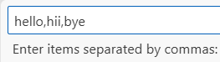
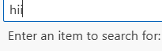
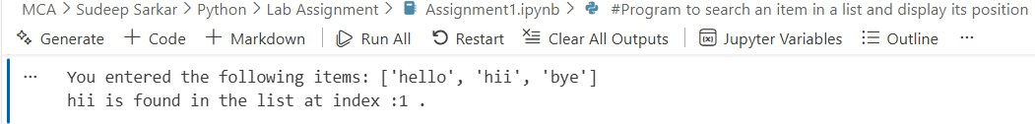

Practical – 5
Aim : Given a list of employee records as dictionaries, sort them by salary and display the sorted list.
Code :
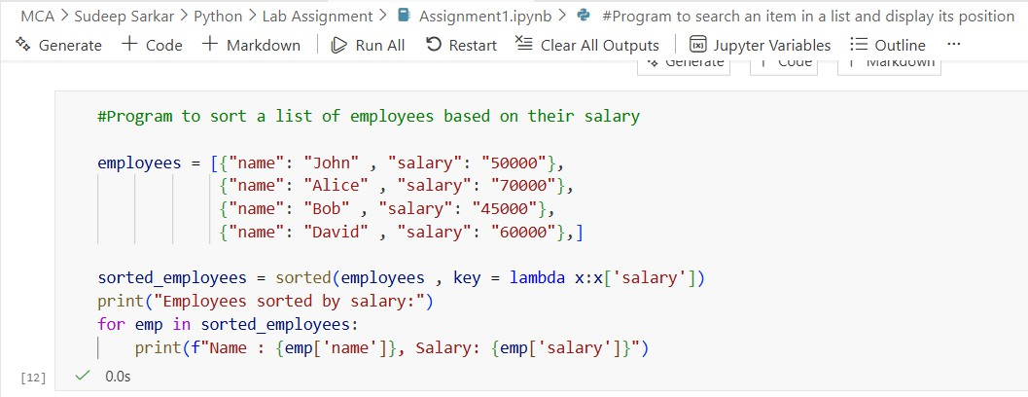
Output :
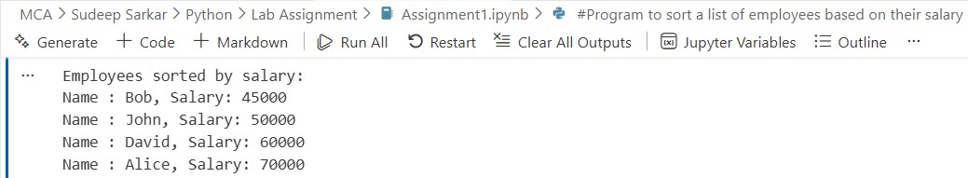

Practical – 6
Aim : Write a program that reads a text file and counts the number of lines, words and characters.
Code :

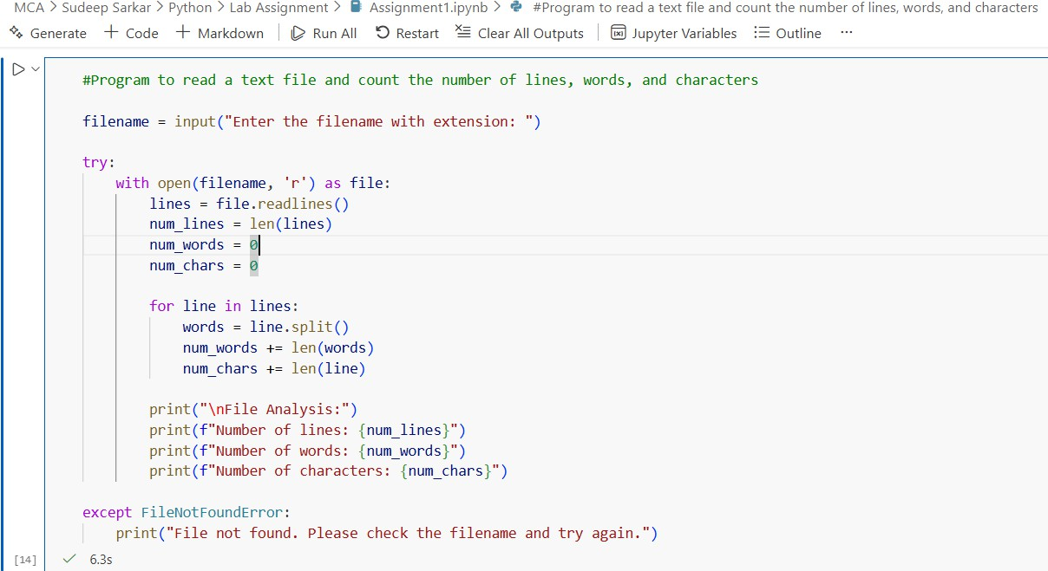
Output :
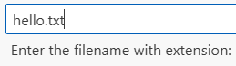
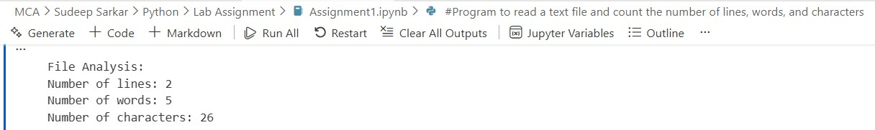

Practical – 7
Aim : Read a sentence and display how many times each word appears, ignoring case and punctuation.
Code :
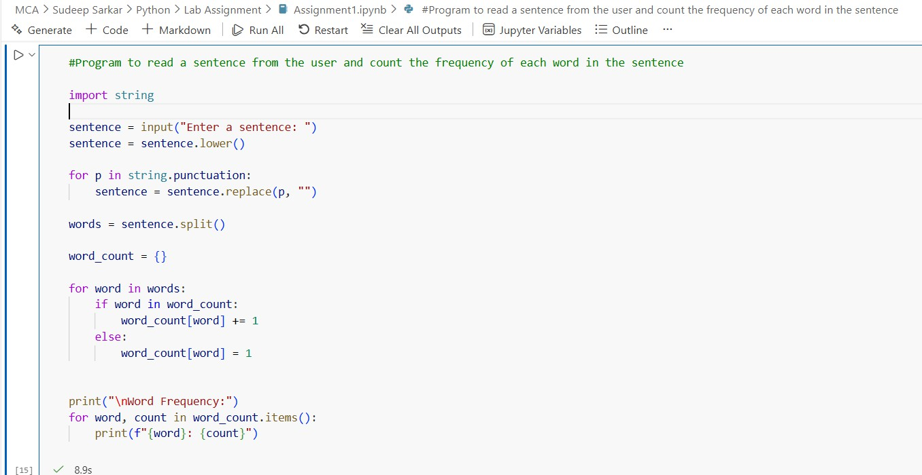
Output :
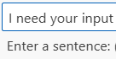
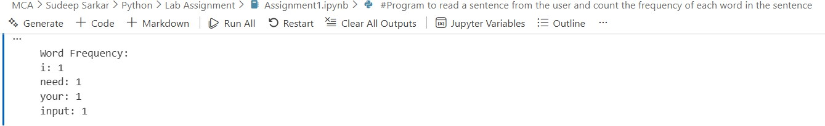

Practical – 8
Aim : Write a Python program that lists all files in a directory and categorizes them by file extension.
Code :
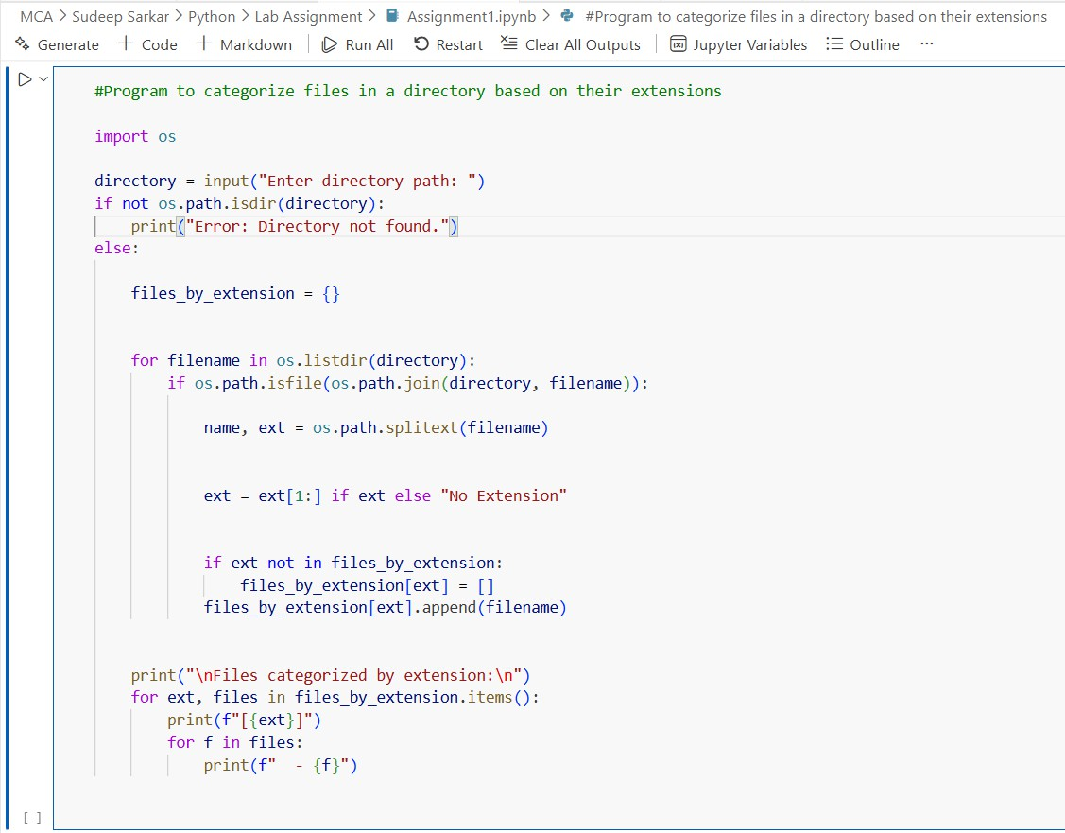
Output :
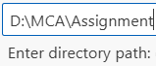
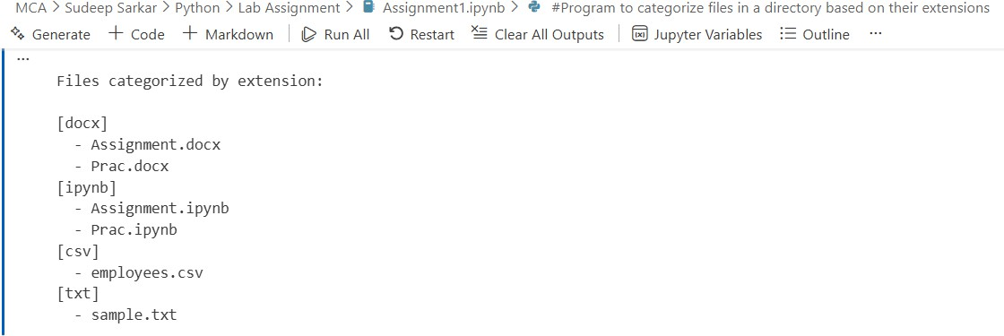
Practical – 09

Aim : Inside the circle.py module, create a class Circle that demonstrates by using a separate Point class (for center coordinates). Write the code for both classes.

Code:

point.py
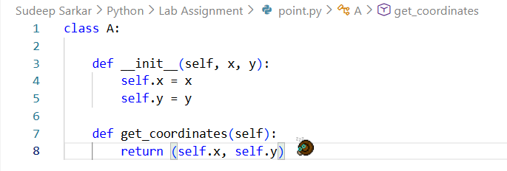

circle.py
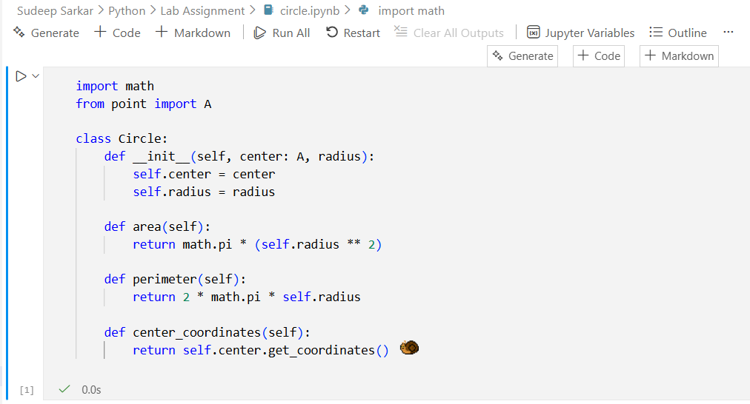

Practical – 10

Aim: Add an __init__.py file inside the shapes package that exposes only Circle and Rectangle using __all__. Write code to show how from shapes import * will work after this.

Module1(__init__.py):

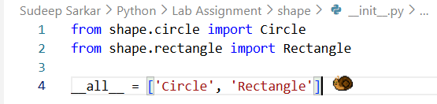

Module2(circle.py)

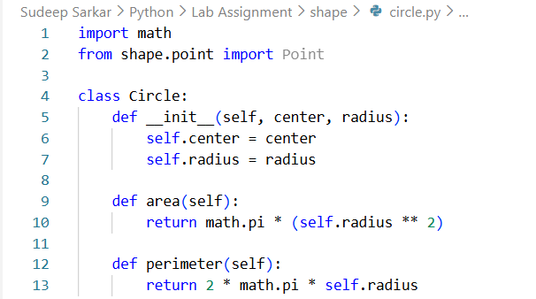

Module3(rectangle.py)

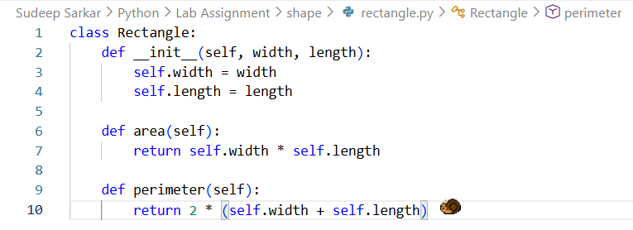

Module 4(point.py)

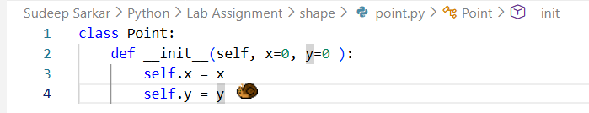

Directory Samples

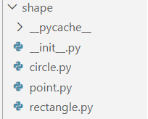

Code:

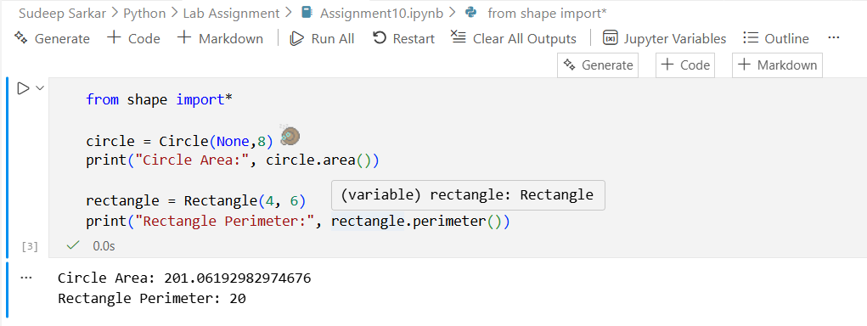

Output:

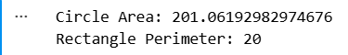

Practical-11

Aim: Write a program in main.py to import the shapes package using both:
- Absolute imports
- Relative imports (inside package)

Module 1(point.py)
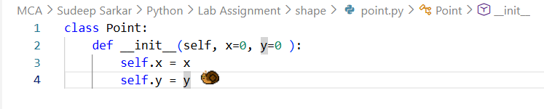

Module 2(circle.py)
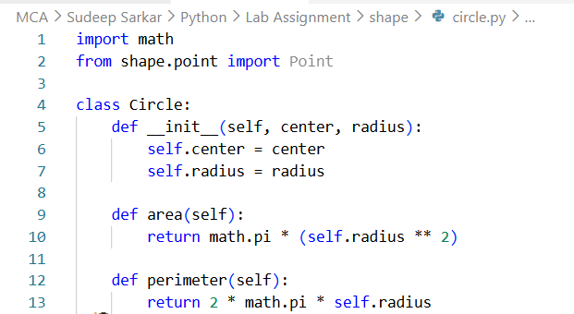

Module 3(rectangle.py)
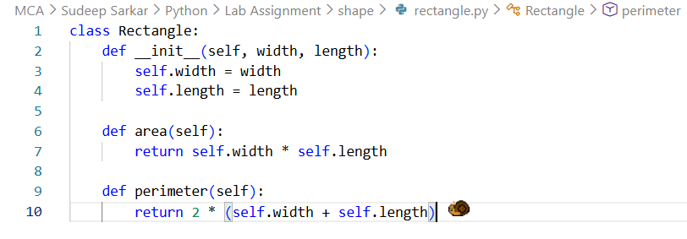
Directory Sample

main.py
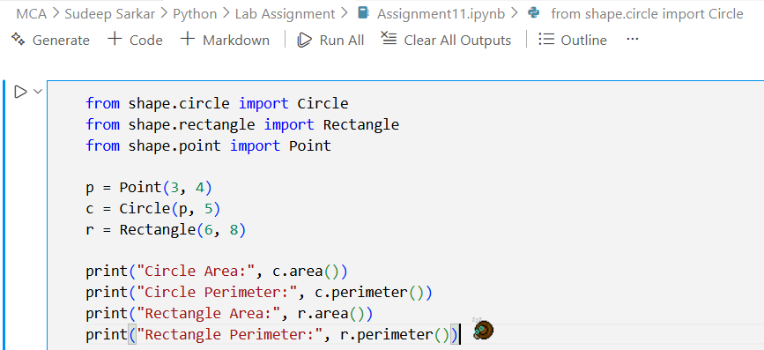

Output:-
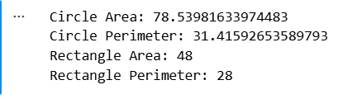

Practical-12
Aim:- Write a Python program that reads two numbers from the user and performs division.
use try-except to handle the following exceptions:
- ValueError (if the user enters non-numeric input)
- ZeroDivisionError (if the second number is zero)
- Display appropriate error messages.

Code:
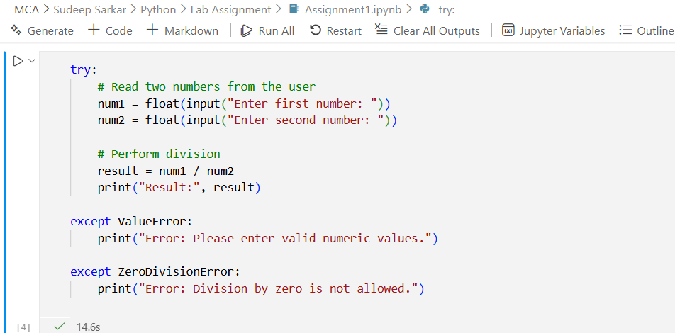

Output:
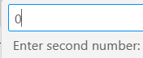

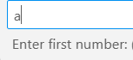
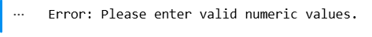

Practical-13

Aim:- Create a Python function read_file(filename) that opens and reads a text file.
Use try-except-finally to handle:
- FileNotFoundError if the file does not exist
- PermissionError if the file cannot be opened
Finally FileNotFoundError block should print "File read attempt completed."

Code:
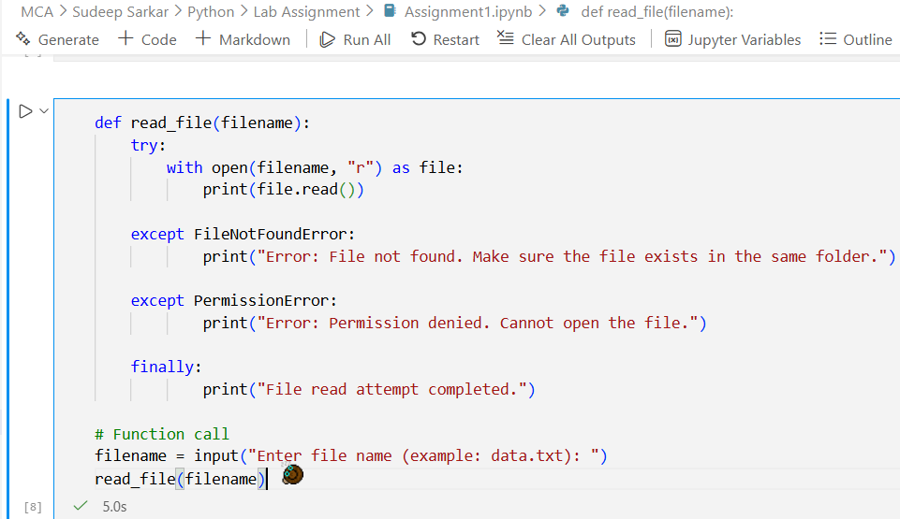

Output:
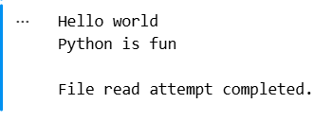

Practical-14

Aim:- Use California Housing datasets to build a Linear Regression model and print MAE and R² score.

Code:
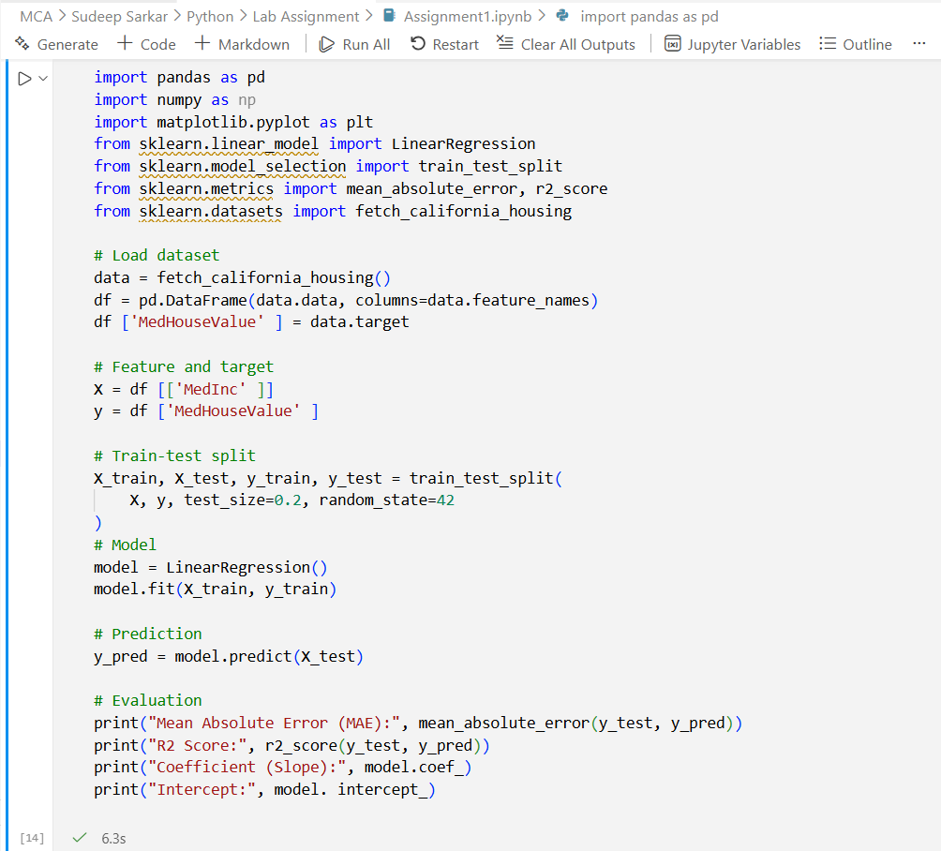
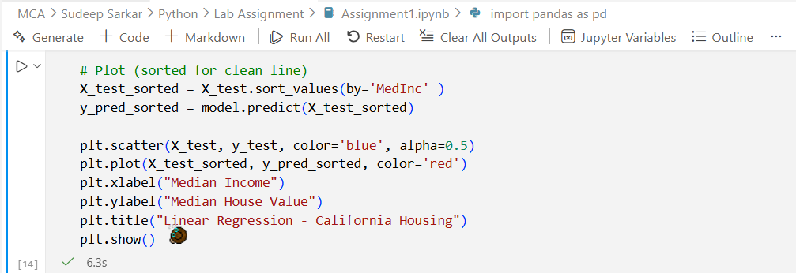

Output:

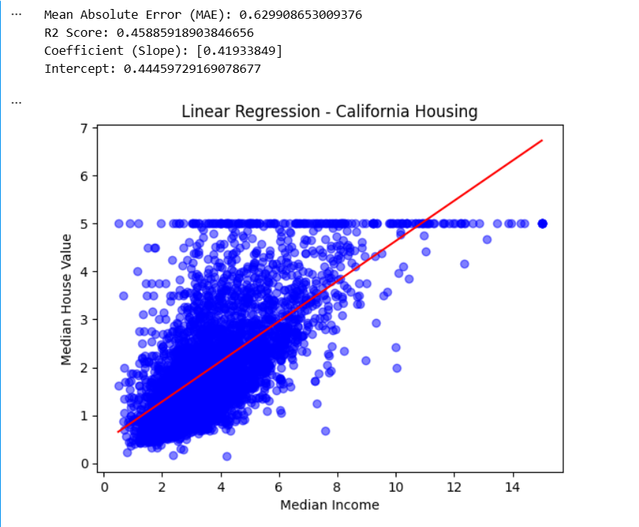

Practical-15

Aim : Perform Agglomerative Hierarchical Clustering on the Iris dataset

Code:
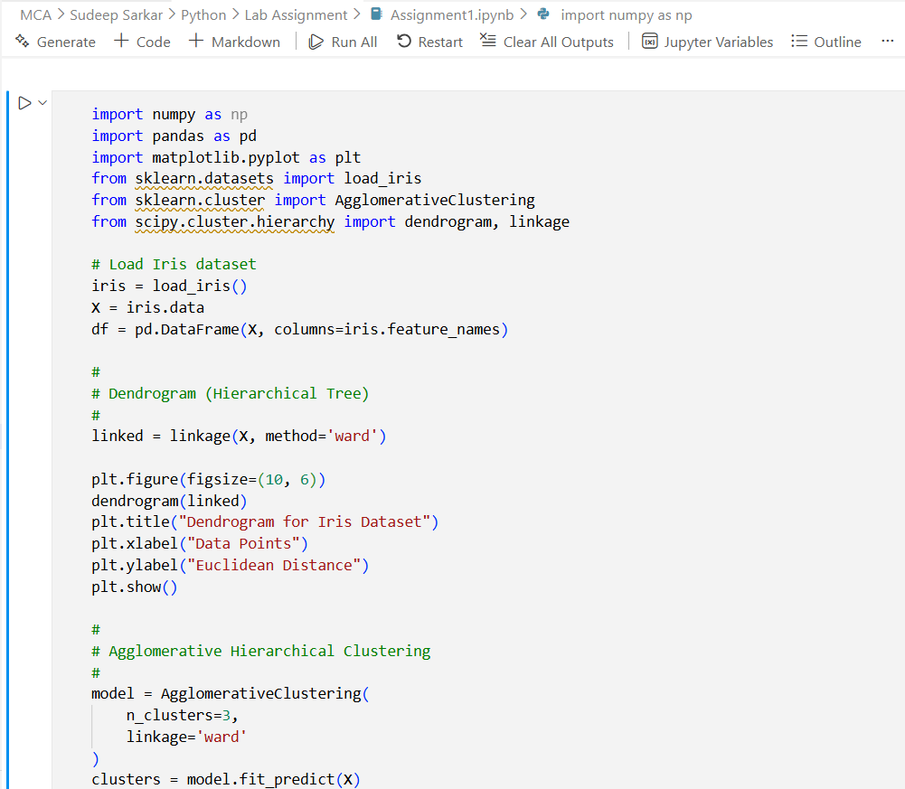
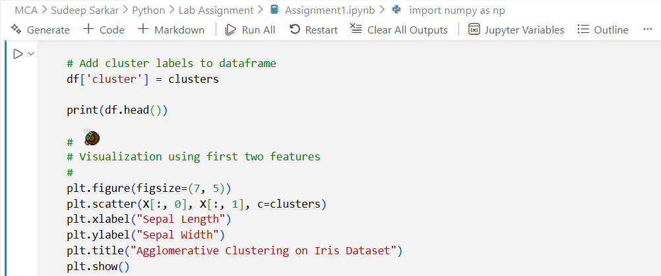

Output:
